**Final Project proposal for ELE: 581**

Name: Muhammad Enayetur Rahman

Student ID: 100635221

Data set: [Airfoil Self-Noise Data Set](http://archive.ics.uci.edu/ml/datasets/Airfoil+Self-Noise)

Total 6 attributes are:

1. Frequency, in Hertz
2. Angle of arrack, in degrees
3. Chord length in meters
4. Free-stream velocity, in meters per second
5. Suction side displacement thickness, in meters

And the final output is:

1. Scaled sound pressure level, in meters

Here is the basic statistical summary for each attribute. Attribute ‘Sound level’ would be my final output regression attribute.

**Summary of each attribute:**

|  |
| --- |
| **frequency** |
| Min. : 200 |
| 1st Qu.: 800 |
| Median : 1600 |
| Mean : 2886 |
| 3rd Qu.: 4000 |
| Max. : 20000 |

|  |
| --- |
| **angle_of_attack** |
| Min. :0.000 |
| 1st Qu.:2.000 |
| Median :5.400 |
| Mean :6.782 |
| 3rd Qu.:9.900 |
| Max. :22.200 |

|  |
| --- |
| **chord_length** |
| Min. : 0.0254 |
| 1st Qu.: 0.0508 |
| Median : 0.1016 |
| Mean : 0.1365 |
| 3rd Qu.: 0.2286 |
| Max. : 0.3048 |

|  |
| --- |
| **free_stream_velocity** |
| Min. : 31.70 |
| 1st Qu.: 39.60 |
| Median : 39.60 |
| Mean : 50.86 |
| 3rd Qu.: 71.30 |
| Max. : 71.30 |

|  |
| --- |
| **displacement_thickness** |
| Min. : 0.0004007 |
| 1st Qu.: 0.0025351 |
| Median : 0.0049574 |
| Mean : 0.0111399 |
| 3rd Qu.: 0.0155759 |
| Max. : 0.0584113 |

|  |
| --- |
| **sound_level** |
| Min. : 103.4 |
| 1st Qu.: 120.2 |
| Median : 125.7 |
| Mean : 124.8 |
| 3rd Qu.: 130.0 |
| Max. : 141.0 |

**Histogram of each independent variable:**

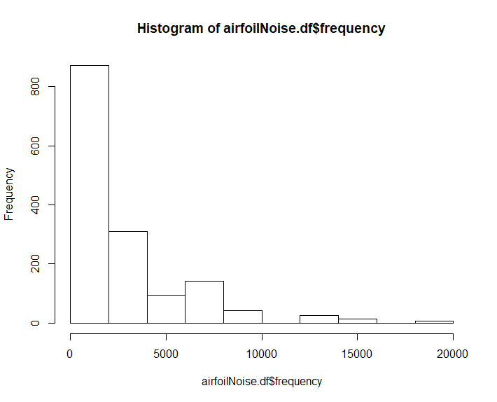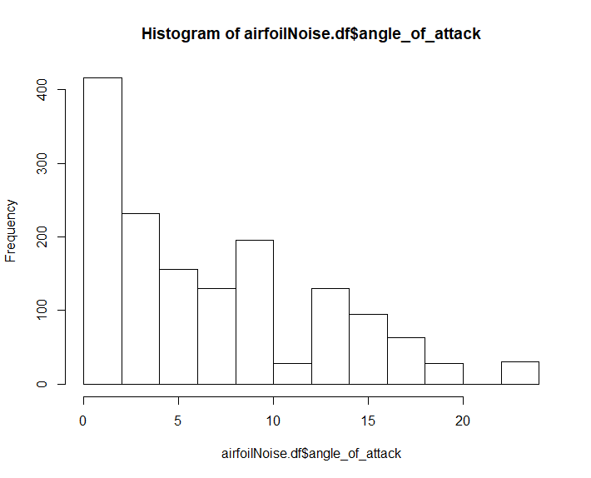

Figure 2: Histogram of Attribute Angle of Attack

Figure 1: Histogram of Attribute Frequency

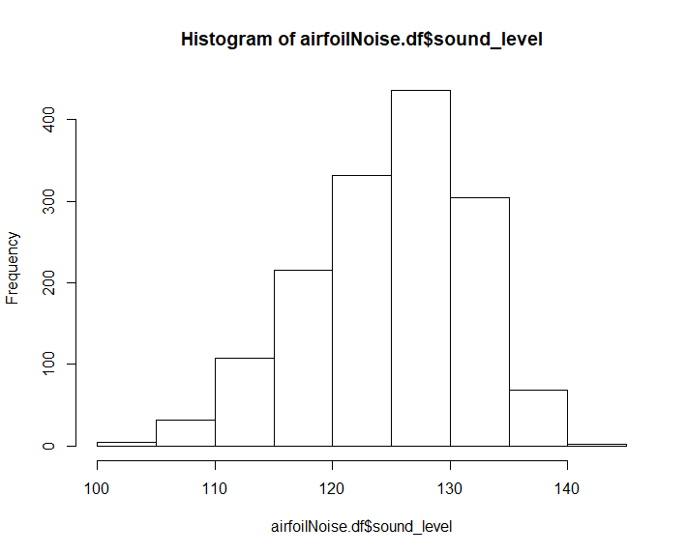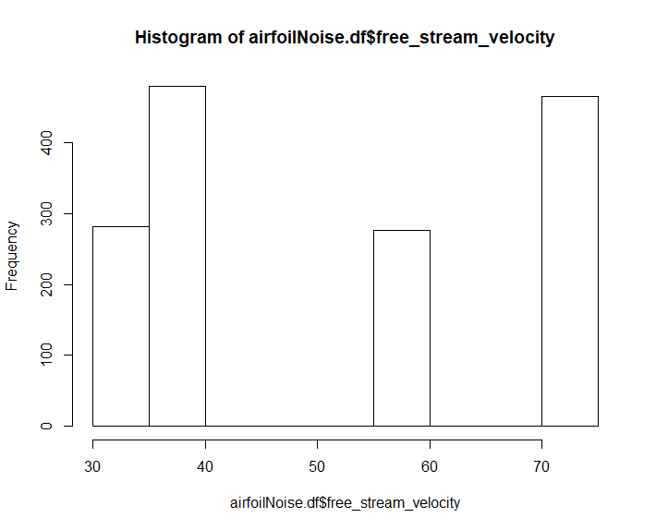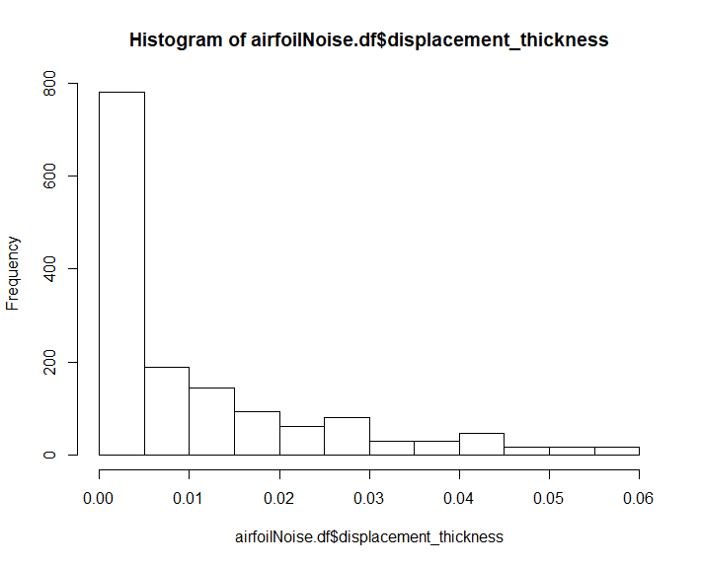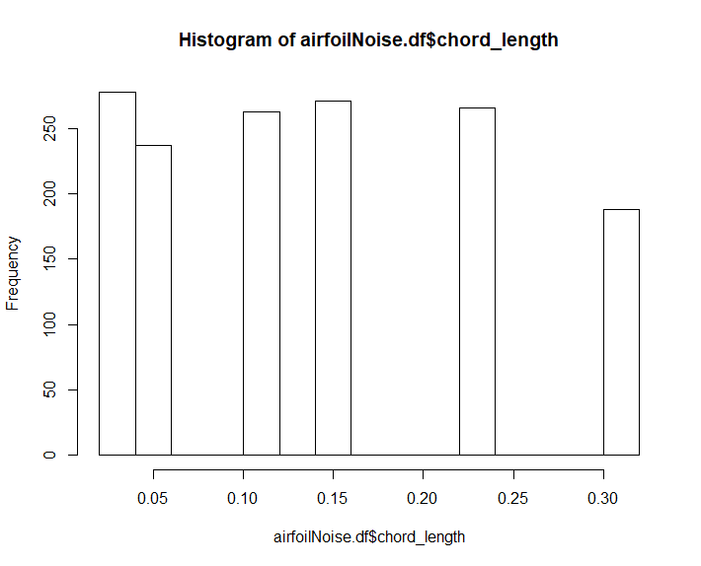

Figure 6: Histogram of Attribute Sound Level

Figure 5: Histogram of Attribute Displacement Thickness

Figure 4: Histogram of Attribute Free stream velocity

Figure 3: Histogram of Attribute Chord Length

**Graphs of each independent variable:**

|  |  |
| --- | --- |
| **Frequency** | **Angle of Attack** |
| **Chord Length** | **Free stream velocity** |
| **Displacement Thickness** | **Sound level** |

**Why using this data set?**

In the final project, I will choose option 1 that is, to build and evaluate support vector machine regression models. For this reason, I chose Airfoil Self-Noise Data Set.

This data set provides the airfoil self-noise which is an important component of the total airframe noise, which is due to the interaction between an airfoil blade and the turbulence produced in its own boundary layer and near wake. This data set provides different size NACA 0012 airfoils at various wind tunnel speeds and angles of attack. In this data set total instances are (rows) are 1503 and total attributes are (columns) are 6.

From the histograms it is seen that, most of the data set contains low frequencies and the target or, output variable has well distributed histogram.